**Arithmetic Calculator**

1. **Arithmetic Calculator:**

**This document contains sections for:**

* Project Description
* [Core concepts used in project](file:///C:\Users\Asus\Downloads\LockedMe%20-%20Virtual%20Key%20for%20Repositories.docx#Core_concepts)
* [Flow of the Application](file:///C:\Users\Asus\Downloads\LockedMe%20-%20Virtual%20Key%20for%20Repositories.docx#Flow).
* Project Users Stories: ( Agile and Scrum )
* Git Repositories
* How to run project
* [Demonstrating the product capabilities, appearance, and user interactions.](file:///C:\Users\Asus\Downloads\LockedMe%20-%20Virtual%20Key%20for%20Repositories.docx#Product_capability)
* [Unique Selling Points of the Application](file:///C:\Users\Asus\Downloads\LockedMe%20-%20Virtual%20Key%20for%20Repositories.docx#USP)
* [Conclusions](file:///C:\Users\Asus\Downloads\LockedMe%20-%20Virtual%20Key%20for%20Repositories.docx#Conclusions)

The code for this project is hosted at :

<https://github.com/KUSALA-sura/Phase-1-ArithmeticCalculator/tree/master>

The project is developed SURA KUSALA.

* 1. **Project Description:**

**Project objective:**

As a developer, write a program to create an arithmetic calculator.

**Background of the problem statement:**

As a developer, write a Java code to create a calculator to perform the four basic arithmetic operations (addition, subtraction, multiplication, and division).

**You must use the following:**

* Eclipse/IntelliJ: An IDE to code for the application
* Java: A programming language
* Git: To connect and push files from the local system to GitHub
* GitHub: To store the application code and track its versions
* Core Java concepts: Variables, data types, operators, type casting, control statements, class, objects, access specifiers, and core keywords like final, this, and static

**Following requirements should be met:**

* The versions of the code should be tracked on GitHub repositories.
* The *calculator*should work properly.

1. **Architecture diagram / flow chart**

**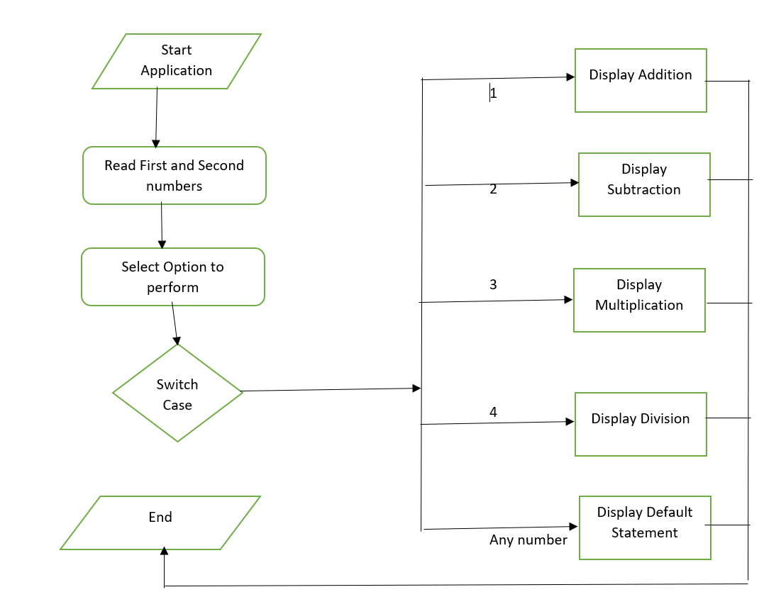**

* 1. **Project Users Stories : ( Agile and Scrum )**

The project is planned to be completed in 2 sprints. Tasks assumed to be completed in the sprint are:

* Creating the flow of the application
* Initializing git repository to track changes as development progresses.
* Writing the Java program to fulfill the requirements of the project.
* Testing the Java program with different kinds of User input
* Pushing code to GitHub.

1. As a Developer, I can change the options of the operations that can be done.
2. As a User, I can get Result of Arithmetic Operation like Addition.
3. As a User, I can get Result of Arithmetic Operation like Subtraction.
4. As a User, I can get Result of Arithmetic Operation like Multiplication.
5. As a User, I can get Result of Arithmetic Operation like Division.
6. As a User, I can get Result of Division by zero operation.

The goal of the company is to deliver a high-end quality product as early as possible.

Sprint 1

1) As a Developer, I can change the options of the operations that can be done.

2) As a User, I can get Result of Arithmetic Operation like Addition.

3) As a User, I can get Result of Arithmetic Operation like Subtraction.

Sprint 2

4) As a User, I can get Result of Arithmetic Operation like Multiplication.

5) As a User, I can get Result of Arithmetic Operation like Division.

6) As a User, I can get Result of Division by zero operation.

**3. Project git Repositories**

1. link : https://github.com/KUSALA-sura/Phase-1-ArithmeticCalculator/tree/master

2.clone git : <https://github.com/KUSALA-sura/Phase-1-ArithmeticCalculator/tree/master.git>

## **4 .Demonstrating the product capabilities, appearance, and user interactions**

To demonstrate the product capabilities, below are the sub-sections configured to highlight appearance and user interactions for the project:

## **5 .Unique Selling Points of the Application**

1. Calculations can be maintained easily.
2. Any options to operations can be edited easily.
3. High security for the data as the admin only can access the data.**Conclusions**

In the program an application has been developed with a duration of two spirits. This application makes handling the data of the Arithmetic Calculator.

1. **Screenshots**

**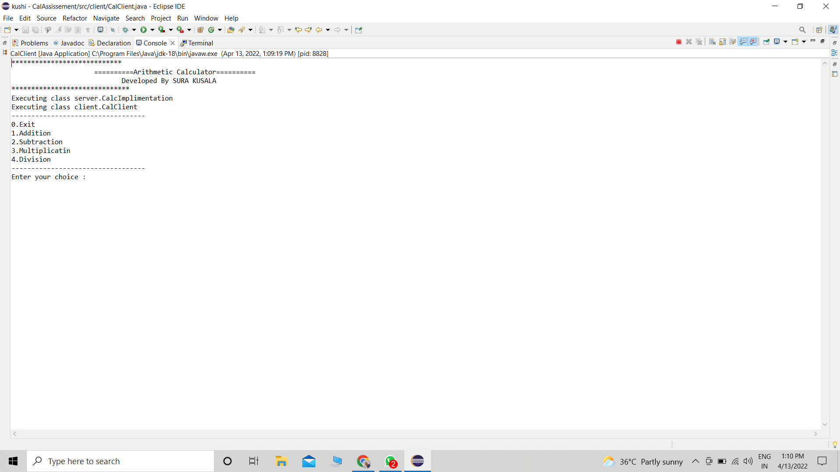**

**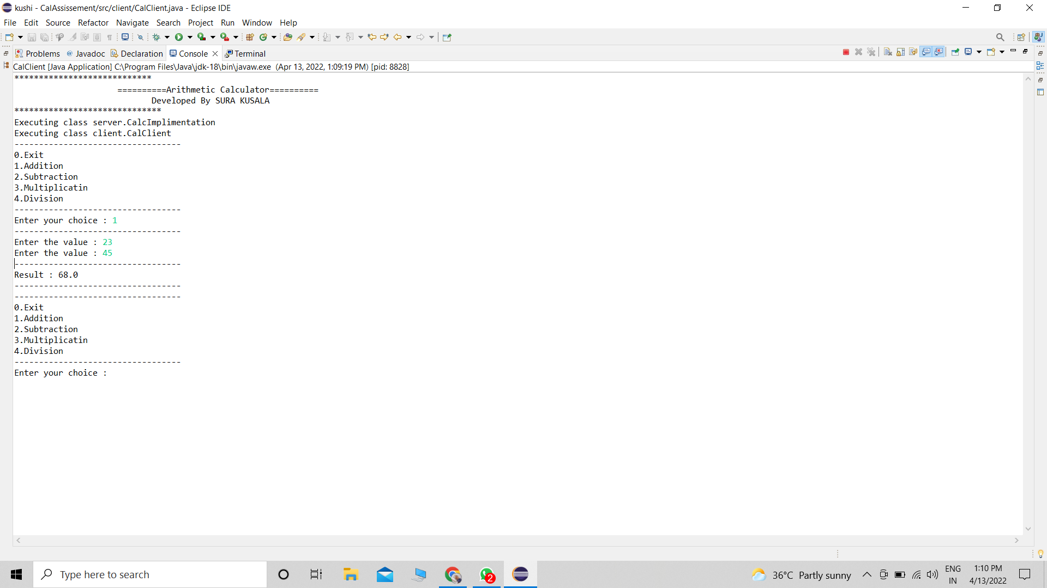**

## **C:\Users\SURA KUSALA\Desktop\simpleearn live classes\Simplilearn_Modolue-1\Arthametic-Cal-Assessement\Outputs\Screenshot (78).png**

## **C:\Users\SURA KUSALA\Desktop\simpleearn live classes\Simplilearn_Modolue-1\Arthametic-Cal-Assessement\Outputs\Screenshot (79).png**

## **C:\Users\SURA KUSALA\Desktop\simpleearn live classes\Simplilearn_Modolue-1\Arthametic-Cal-Assessement\Outputs\Screenshot (80).png**

## **C:\Users\SURA KUSALA\Desktop\simpleearn live classes\Simplilearn_Modolue-1\Arthametic-Cal-Assessement\Outputs\Screenshot (81).png**

## **8 .Conclusions**

1. In the program an application has been developed with a duration of two spirits. This application makes handling the data of the Arithmetic Calculator